STUDENT FIRST NAME / LAST NAME:

CLASS:

**ALGORITHM EXAM #2**

**1h**

|  |  |
| --- | --- |
| SCORE | / 100 |
| COMMENT |  |

**WARNING /!\**

**YOU NEED TO CHECK CAREFULLY STEP BY STEP THAT YOUR CODE WORKS**

**If you code does not work, you will get a 0 score**

**DO NOT USE INSTRUCTION OR CONDITION THAT ARE NOT ALLOWED**

**Exercise 1 (15 POINTS)**

Complete the table. Use a new line every time my_number changes

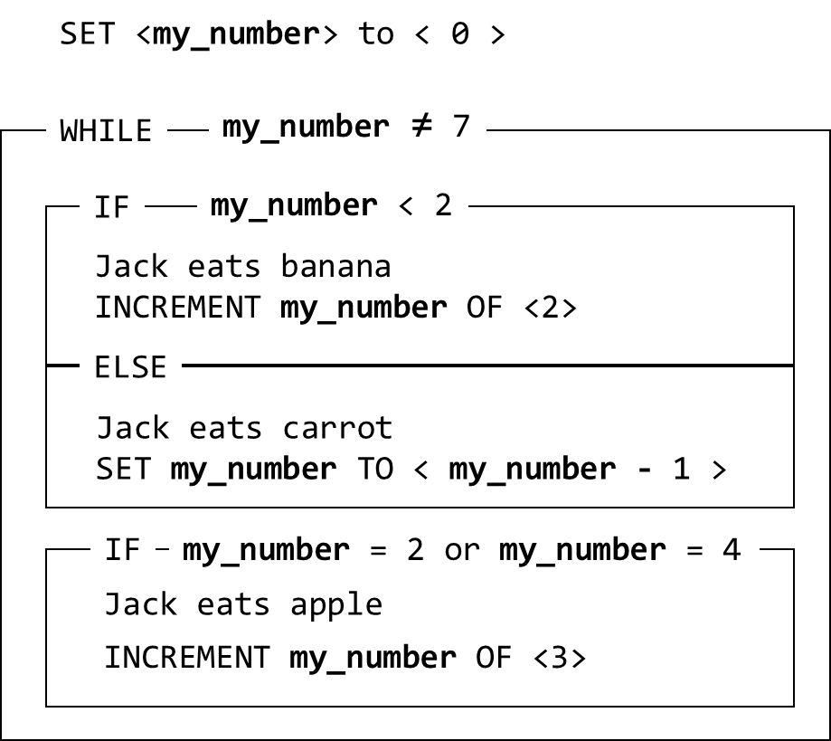

|  |  |
| --- | --- |
| my_number | What Jack eats? |
| 0 | banana |
| 2 | apple |
| 5 | apple |
| 7 |  |
|  |  |
|  |  |

**Exercise 2 (15 POINTS)**

Draw the path of Jack (with arrows )

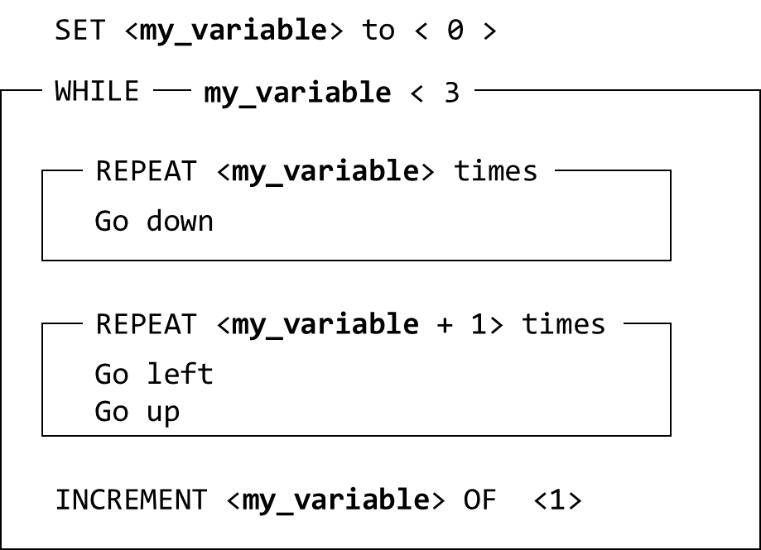

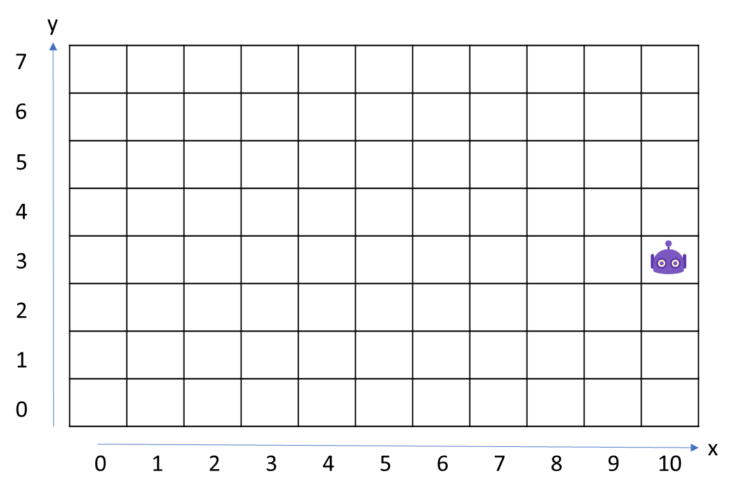

**Exercise 3 (25 POINTS)**

|  |  |
| --- | --- |
| Objective | * Count the score:   If has cell diamond: +2 points  If has cell carrot: +3 points   * Write the score on the last cell   **Warning: your code must work for the 2 cases!!!!** |
| Maximum number of instructions | 10 |
| Allowed instructions | GO-RIGHT IF <CONDITION>  SET <**score**> TO < > IF <CONDITION> ELSE INCREMENT <**score**> OF < >  REPEAT < > TIMES WRITE <**score**>  <**score**> |
| Allowed conditions | <HAS CARROT>  <HAS DIAMOND> |

**CASE 1**



**CASE 2**



SET <**score**> TO < 0 >

WRITE <**score**>

REPEAT < 7 > TIMES

GO-RIGHT

IF < HAS CARROT >

INCREMENT <**score**> OF < 3 >

INCREMENT <**score**> OF < 2 >

IF <has diamond>

**Exercise 4 (20 POINTS)**

|  |  |
| --- | --- |
| Objective | * Pick up all apples |
| Allowed instructions | GO-RIGHT GO-UP PICK-UP IF <CONDITION>  SET <**number_apple**> TO < > IF <CONDITION> ELSE INCREMENT <**number_apple**> OF < >  REPEAT < > TIMES WRITE < **number_apple** >  < **number_apple** > WHILE <CONDITION> |
| Allowed conditions | ***NO CONDITION ALLOWED*** |

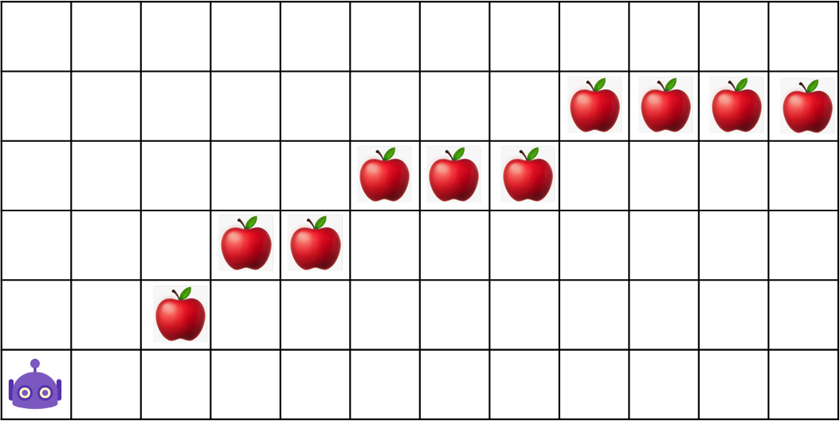

1

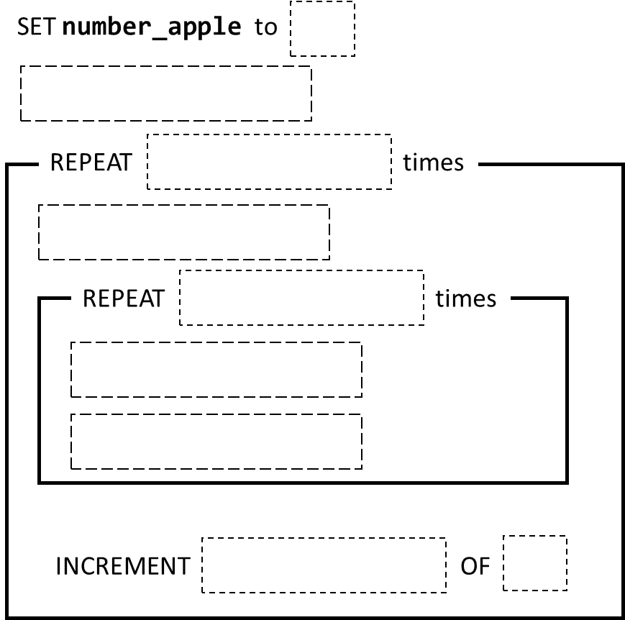

1

**number_apple**

PICK-UP

GO-RIGHT

**number_apple**

GO-UP

GO-RIGHT

**number_apple**

**Exercise 5 (25 POINTS)**

|  |  |
| --- | --- |
| Objective | * For each lines: there is a number N. Paint N cells on the right side this number * But if cell has a cross, do not pain the cell   *For instance , for case 1 , the result will be :*    **Warning: your code shall work for the 2 cases!!!!** |
| Max number of instructions | 10 |
| Allowed instructions | GO-RIGHT  GO LEFT REPEAT < > TIMES  GO DOWN  GO UP  PAINT  Variables:  SET <**number_of_paint**> TO < >  <**number_of_paint**>  <VALUE ON CELL> |
| Allowed conditions | ***NO CONDITION ALLOWED*** |

**CASE 1**

SET <**number_of_paint**> TO < **number_of_paint** >

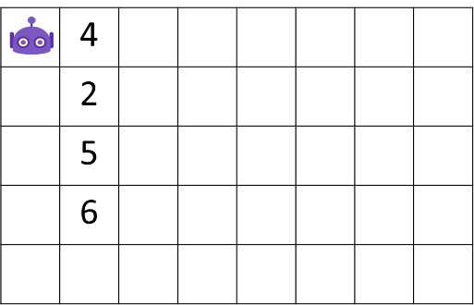

GO-RIGHT

PAINT

REPEAT < VALUE ON CELL > TIMES

REPEAT < **number_of_paint**> TIMES

GO-RIGHT

**CASE 2**

